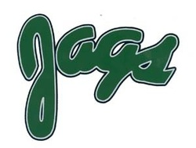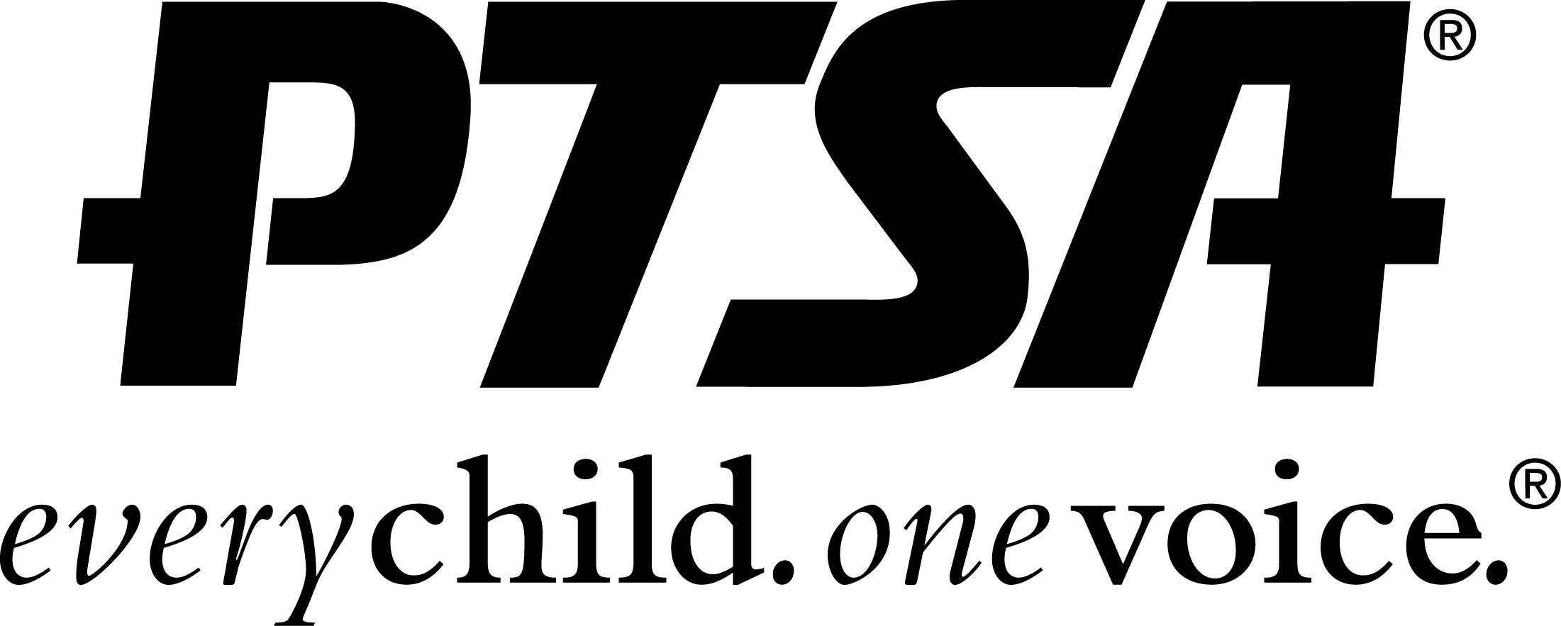APHS PTSA
Jags Stadium Blanket Order Form

*Please print clearly*

Name:

Phone:

Email:

Blankets are $30 each with Jags logo only or $39.00 each with Jags logo, name (first or last name), and grad year.

Quantity ordered:

________ (Jags logo, $30)

________ (with personalization, $39) Please complete personalization info below.

Name on Blanket: Grad Year

Name: Grad Year

Name: Grad Year

Is this a gift? ___________________ If not, we may deliver to your student.
Order forms and payment must be turned in to the APHS Main Office by the end of the school day Monday March 25, 2019

Payment: Cash or Check
**Make checks payable to APHS PTSA**

Credit/debit card orders** can be placed online at
https://aphsptsa.memberhub.store/
**service fee applies

Any questions, please contact Denise Crank by email at denisecrank@yahoo.com
*Delivery will be middle of April
*Any changes/corrections made after the order is sent/delivered that are not the fault of the manufacturer or printing company will be made at the customers expense*
*Blankets are green Gildan sweatshirt fabric, 50" x 60" in size

**All returned checks are subject to a $25 returned check fee**

